 **NARROGIN SENIOR HIGH SCHOOL** 

**Year 10 NAEP and General English**

|  |
| --- |
| **Student: Teacher: Date Due:** 26/10/2020 |
| **Assessment Type: Writing**  **Task 16**  **Writing Journal – Object Writing**  Object Writing is a creative writing task which involves looking at an object and then creating a story with that object as the stimulus. How prominent the object is in the story is up to you.  This task will comprise of three sections:  **Part One**: You are to read the examples given, then attempt your own object writing using the prompt provided.  **Part Two:** You are to find an image which you think you can write a story about and print out the image. Then create a draft of your story using that object as your stimulus.  **Part Three:** Produce a final version of your story. It should be **1-2 pages** in length (**no more than 600 words**)  **Time allocation:** 1 week  **Conditions:** In class – notes allowed.    **Weighting:** Writing – 5% |

**Teacher Feedback:**

**Marking Criteria: Writing**

|  |  |
| --- | --- |
| **CRITERIA AND CATEGORIES** | Marks  /30 |
| **Creating and Responding** | **10** |
| Creates innovative and engaging creative work that explores complex ideas and issues. | 8 - 10 |
| Creates engaging creative work that explores challenging ideas and issues. | 6.5 - 7.5 |
| Creates creative work that identifies challenging ideas and issues. | 5 – 6 |
| Creates formulaic creative work that attempts to identify ideas about challenging ideas and issues. | 3 – 4.5 |
| Does not meet the requirements of a D grade. | 0 – 2.5 |
| **Language features** | **10** |
| Uses a wide range of complex and appropriate vocabulary and grammar, making selections which contribute to an effective and engaging text. | 8-10 |
| Uses a range of vocabulary and grammar appropriate to the audience, purpose and context when creating a text. | 6.5-7.5 |
| Selects grammar and varies vocabulary choices for impact. | 5-6 |
| Uses mostly correct grammar and appropriate vocabulary in familiar texts. | 3-4.5 |
| Does not meet the requirements of a D grade. | 0-2.5 |
| **Editing** | **10** |
| Consistently uses a range of editing strategies to demonstrate control over sequencing of ideas, selection of vocabulary, spelling, grammar and punctuation, with an awareness of the purpose, audience and context of the text. | 8-10 |
| Monitors and edits own work effectively for accuracy of vocabulary, spelling, grammar and punctuation, and to achieve specific effects. | 6.5-7.5 |
| Edits vocabulary, grammar, spelling and punctuation to improve clarity. | 5-6 |
| Identifies most errors in punctuation, spelling or word choice, and attempts to rewrite words or insert punctuation. | 3-4.5 |
| Does not meet the requirements of a D grade. | 0-2.5 |
| **TOTAL** | **/30** |

**Green Sphere**

By [Rebecca Coffey](http://significantobjects.com/author/rcoffey/)

[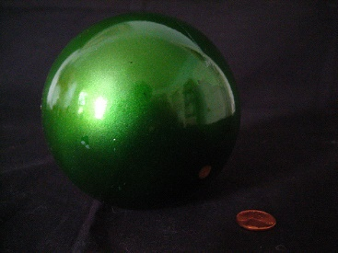](http://cgi.ebay.com/ws/eBayISAPI.dll?ViewItem&item=250615778417)

It was all because of what happened the Halloween she was eight. We’d had pumpkin soup and near-beer for dinner. The soup gave her gas.

But it also gave her a dream. A full moon was falling. Getting bigger and bigger as it fell, it made a wind that moved everything on earth in fast motion and that blew into Masie’s brain a vision of the shape of her life. She was going to die when the moon hit earth. Her life would be short. But considering that she’d get to see the world end, it would be unusually full. The shape of her life was going to be spherical.

Masie’s gas pains woke her before the moon could hit the ground. The next day, she started playing marbles alone every afternoon in the dust outside.

“This game was brought to you by the number 8 and the letter O,” she’d announce at game’s end.

She also wore my padded bras to give herself something round up top. Now, of course, she’s grown two big globes on her chest. Each morning, in a movie star voice, she says, “You, girls, are the shape of life,” and puts on her bra.

Well, the shape of life is also what spit bubbles, ants’ butts, bowling balls, and cat testicles are. Roundness is the whole deal for Masie. Spheres are best, but circles will do. Her favorite thing about Harry Potter is his glasses. Her favorite part of sadness is tears. My pills are what she likes most in our bathroom. Sitting on the pot, she pours them into her hand and watches them roll around.

The other night, she dreamed one of my green chloral hydrates got huge just like the moon did in her dream when it fell. But that’s not the night my chloral hydrate almost killed her.  
  
Last night was the night. Happy Halloween, right? I offered to make pumpkin soup, but she wanted to order Chinese. It took her forever to eat Buddha’s Delight. She removed each snow pea from its pod and rolled it on her tongue. After, she had a Tootsie Pop. And when she got into bed, she dumped a whole sack of marbles around herself. She had her ants’ butts collection in a jar by her pillow, and hubcaps at the four corners of her room.

“Tonight is the night, Mom,” she said from under her covers.

She wouldn’t answer when I asked, “For what?”

I took my chloral hydrate and fell asleep in my underwear on the couch.

But then the wind started to blow. Something made a noise. Masie’s gas? The moon crashing through trees? Whatever. Lucky me.

I woke not 20 minutes after Masie and I had gone to sleep. Which was good, because she had eaten all my green pills, three smiley face buttons, and an orange.

**Jar of Flowers**

By [Sarah Manguso](http://significantobjects.com/author/sarah-manguso/)

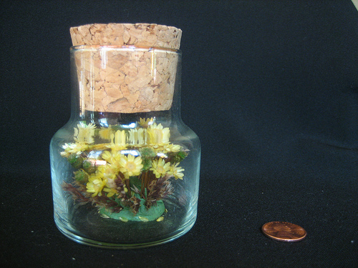

When the old lady died, my brothers and I were told to take away everything that was left.

The knickknack shelf was dusty. The porcelain things were gone, and so was the tiny violin. There were some pastel-glazed animals, a jar of flowers, a clay thimble, and other things of no value. I looked at the little paper man, his paper face with its painted mustache and his hollow belly that hid a metal weight. My grandmother bought it in Spain after watching a man somersault it up and down his forearm as he sang in a pure tenor on a cobblestone street. Can you see him, young and smooth-faced, the light on the windows of the church behind? I can. My grandmother wore a gold bracelet with a charm from every country she’d ever been to.

It was cold in the apartment and we kept our coats on as we packed and sorted. I have never seen my brothers cry except when one of them knocked out three of the other one’s teeth.

All the tiny things were wrapped in tissue and put into boxes and then into a crate to donate to the church. I didn’t see my brothers take anything but I pocketed the corked jar because I knew it wouldn’t get crushed in my pocket on the way home. It was the size of an apricot. The flowers inside were real, or had been made to look real. They were stuck to the base of the jar with some putty.

I’ve kept the jar in a drawer since then. I don’t know where it came from. When I open the drawer and see it rolling around, a flicker of yellow, I remember my grandmother’s shiny yellow kitchen table, and the soft yellow hand towels, and all the yellow scarves and things she liked to wear. And then I can see the whole apartment and the parquet floors and the shelves and the little paper man.

**Felt Mouse**

By [Meghan O'Rourke](http://significantobjects.com/author/meghan-o-rourke/)

[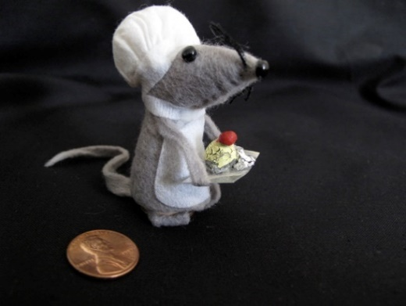](http://cgi.ebay.com/ws/eBayISAPI.dll?ViewItem&item=250524566584#ht_500wt_1182)

After my mother died, a stranger emailed me. He told me that my mother had been the most important person in his life. They went to Catholic school together. He was unpopular, she was popular; he was a bad student, she was a good student; he was a football player; she was a cheerleader. Though he wasn’t in her clique, one night at a dance, she came up to him while “Hey Jude” was playing and asked him to dance. Something clicked.

They told each other everything, walking home from school carrying books, talking on the phone for hours at night, to the annoyance of siblings and parents. (This was before call waiting.) One day after school they went to the beach club and swam in the ocean for hours, talking, sitting on the rope buoys. Her lips got blue. He told her they should go in, but sitting on the furthest buoy, she said, let’s just stay out here a while longer. The two of them sat together under the big sky, listening to the cries of the birds, as if they were made for water.

The other boys in her clique got annoyed that my mother was spending so much time with this guy. One of them tackled him hard during football practice and broke his wrist. So this guy decided, with regret, it was time for him to leave my mother alone. First, though, he made her Mario, the baker mouse. It took him three days of work after school. Mario is made of soft felt, string, and paper. If his feet are not really there, that is because this young man was not much of an artist.

When I was a child, my mother used to keep Mario on a shelf near the oven. Sometimes I would play with him. She told me that Mario was magic; in the night, he made muffins light as manna and delicate as silver. If you happened to sleepwalk into the kitchen, you could eat the muffins, but they disappeared by morning. I always hoped I might sleepwalk, because the muffins, my mother said, cast a spell on you. If you ate one, your dreams would be vivid. You would feel light and airy when you wake, not tired. You would finally remember that feeling which always seemed like a secret you couldn’t name, and carry it around with you.

Soon after the man gave Mario to my mother, she met my father.  She married my father a year later, when she was 17. There was nothing more between my mother and this man. Then one day last year, he Googled my mother. He saw her death notice. And he contacted me to tell me about Mario.

For these reasons, I believe Mario is good luck. He is made out of feelings as much as he is made of felt. And his favorite thing to bake is red velvet cupcakes.

Have a go yourself:

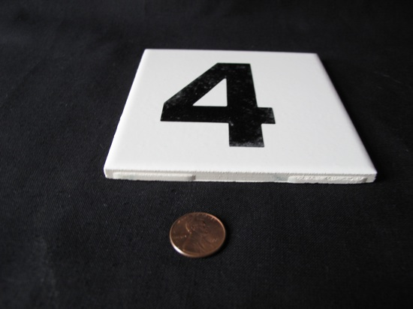

|  |
| --- |
|  |
|  |
|  |
|  |
|  |
|  |
|  |
|  |
|  |
|  |
|  |
|  |
|  |
|  |

|  |
| --- |
|  |
|  |
|  |
|  |
|  |
|  |
|  |
|  |
|  |
|  |
|  |
|  |
|  |
|  |
|  |
|  |
|  |
|  |
|  |
|  |
|  |
|  |
|  |
|  |
|  |
|  |
|  |

**Part Two:**

Use this page to either paste or staple your photo to.

Use the space below to create a draft of your story:

|  |
| --- |
|  |
|  |
|  |
|  |
|  |
|  |
|  |
|  |
|  |
|  |
|  |
|  |
|  |
|  |
|  |
|  |
|  |
|  |
|  |
|  |
|  |
|  |
|  |
|  |
|  |
|  |
|  |

|  |
| --- |
|  |
|  |
|  |
|  |
|  |
|  |
|  |
|  |
|  |
|  |
|  |
|  |
|  |
|  |
|  |
|  |
|  |
|  |
|  |
|  |
|  |
|  |
|  |
|  |
|  |
|  |
|  |

**Part Three:** Use the space below to create your final copy of your story.

|  |
| --- |
|  |
|  |
|  |
|  |
|  |
|  |
|  |
|  |
|  |
|  |
|  |
|  |
|  |
|  |
|  |
|  |
|  |
|  |
|  |
|  |
|  |
|  |
|  |
|  |
|  |
|  |
|  |

|  |
| --- |
|  |
|  |
|  |
|  |
|  |
|  |
|  |
|  |
|  |
|  |
|  |
|  |
|  |
|  |
|  |
|  |
|  |
|  |
|  |
|  |
|  |
|  |
|  |
|  |
|  |
|  |
|  |